Week 20 - Monday 18 March 2024
Olde Tavern Allsorts vs Kippax Legionnaires
The Vic vs Olde Taverners
Upton Bees vs Lofthouse Lions
BYE – Flanagan's Army

Week 21 - Monday 25 March 2024
Flanagan's Army vs Olde Tavern Allsorts
Lofthouse Lions vs The Vic
Olde Taverners vs Upton Bees
BYE – Kippax Legionnaires

Monday 1 April 2024 – No matches – Easter Monday Bank Holiday

Monday 8 April 2024 – Knockout Cup Semi–Final/Plate Knockout Semi–Final

Monday 15 April 2024 – Handicap Cup Round One

Monday 22 April 2024 – Handicap Cup Round Two

Monday 29 April 2024 – Handicap Cup Semi–Final

Monday 6 May 2024 – No matches – May Day Bank holiday

Monday 13 May 2024 – Handicap Cup Final & Pairs – venue tba

Monday 20 May 2024 – Knockout Cup Final/Plate Knockout Final – venue tba

Name | Address and contact
Carleton Grangers | The Grange Club, Carleton Road, Pontefract. WF8 3RJ - 01977 702911.  Contact Mick Edwards - 01977 704211.
Featherstone Hotel Phoenix | Featherstone Hotel, Station Lane, Featherstone, Pontefract. WF7 6EW - 01977 791851. Contact Ian Moore – 07725 176806
Flanagan's Army | Upton Arms, 2 High Street, Upton, Pontefract, West Yorkshire, WF9 1HG - 01977 650495. Contact Duncan Cooper 01302 850716 – 07549 659289.
Golden Lion Dudes | The Golden Lion, The Square, Ferrybridge, Knottingley. WF11 8ND - 01977 324429.  Contact Steve Scott - 07901 922033.
King’s Arms | The King’s Arms, Heath Common, Heath, Wakefield. WF1 5SL – 01924 377527  Contact Tim Lee - 07527 575096.
Kippax Ex-Service Club | Kippax British Legion, Church Lane, Kippax, Leeds. LS25 7HF - 0113 286 9739.  Contact David Oldfield - 0113 286 6861 - 07931 136237.
Kippax Legionnaires | Kippax British Legion, Church Lane, Kippax, Leeds. LS25 7HF - 0113 286 9739.  Contact Ian Sutton – 07909 268972 – 0113 286 3797.
Lofthouse Lions | The Thatched House, 434 Aberford Road, Stanley, Wakefield. WF3 4AA – 01924 823361 - Contact Dave Bill – 07979 100215
The Vic | The Vic, 47 Manor Road, Ossett, Wakefield. WF5 0AU – 01924 273516.  Contact Glen Scholey – 07751 720757.
Olde Tavern Allsorts | The Olde Tavern, South Baileygate, Pontefract. WF8 2JL - 01977 780619.  Contact David Leigh - 07900 490418.
Olde Taverners | The Olde Tavern, South Baileygate, Pontefract. WF8 2JL - 01977 780619.  Contact Nick Clapham - 07443 036785 - 01977 798043.
The Other Team | Featherstone Hotel, Station Lane, Featherstone, Pontefract. WF7 6EW - 01977 791851. Contact Debby Aspland – 07870 346851 – 01977 792154.
Upton Bees | Upton Arms, 2 High Street, Upton, Pontefract, West Yorkshire, WF9 1HG - 01977 650495. Contact Stuart Topps – 01302 300906, 07946 713117 – 07946 191686 (Helen Topps)
THE FIVE TOWNS QUIZ LEAGUE

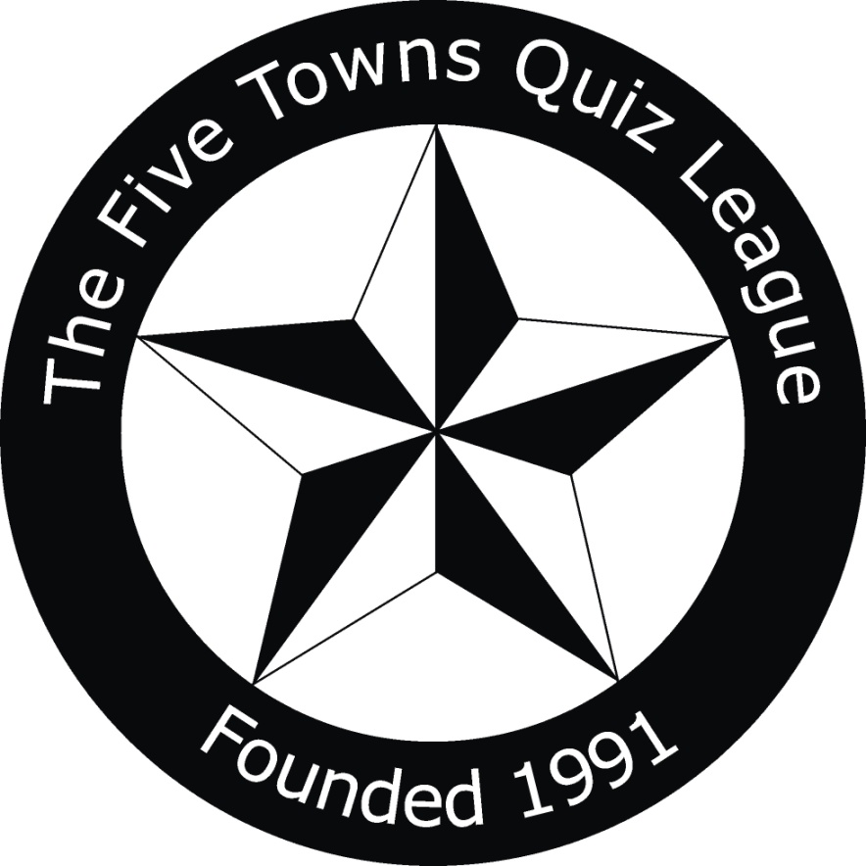

Layers Cleaning

FTQL 32!

2023-24 Season Fixtures
Division One

The Five Towns Quiz League 2023-24 Season Fixtures Division One

Monday 25.09.23 – Season-opening Charity Event at the Featherstone Hotel – commence 8.30pm.

Week 1 - Monday 2 October 2023
Flanagan's Army vs Olde Taverners
Kippax Legionnaires vs Lofthouse Lions
Olde Tavern Allsorts vs Upton Bees
BYE – The Vic

Week 2 - Monday 9 October 2023
Lofthouse Lions vs Flanagan's Army
Olde Taverners vs Olde Tavern Allsorts
The Vic vs Kippax Legionnaires
BYE - Upton Bees

Week 3 - Monday 16 October 2023
Flanagan's Army vs The Vic
Kippax Legionnaires vs Upton Bees
Olde Tavern Allsorts vs Lofthouse Lions
BYE – Olde Taverners

Week 4 - Monday 23 October 2023
Olde Taverners vs Kippax Legionnaires
The Vic vs Olde Tavern Allsorts
Upton Bees vs Flanagan's Army
BYE – Lofthouse Lions

Week 5 - Monday 30 October 2023
Flanagan's Army vs Kippax Legionnaires
Olde Taverners vs Lofthouse Lions
The Vic vs Upton Bees
BYE – Olde Tavern Allsorts

Week 6 - Monday 6 November 2023
Olde Tavern Allsorts vs Kippax Legionnaires
The Vic vs Olde Taverners
Upton Bees vs Lofthouse Lions
BYE – Flanagan's Army

Week 7 - Monday 13 November 2023
Flanagan's Army vs Olde Tavern Allsorts
Lofthouse Lions vs The Vic
Olde Taverners vs Upton Bees
BYE – Kippax Legionnaires

Week 8 - Monday 20 November 2023
Olde Taverners vs Flanagan's Army
Lofthouse Lions vs Kippax Legionnaires
Upton Bees vs Olde Tavern Allsorts
BYE – The Vic

Week 9 - Monday 27 November 2023
Flanagan's Army vs Lofthouse Lions
Kippax Legionnaires vs The Vic
Olde Tavern Allsorts vs Olde Taverners
BYE – Upton Bees

Week 10 - Monday 4 December 2023
Lofthouse Lions vs Olde Tavern Allsorts
The Vic vs Flanagan's Army
Upton Bees vs Kippax Legionnaires
BYE – Olde Taverners

Monday 11 December 2023 – Mid-season meeting – venue tba (KO Cup draw at this meeting)

Week 11 - Monday 18 December 2023
Flanagan's Army vs Upton Bees
Kippax Legionnaires vs Olde Taverners
Olde Tavern Allsorts vs The Vic
BYE – Lofthouse Lions

Week 12 - Monday 8 January 2024
Kippax Legionnaires vs Flanagan's Army
Lofthouse Lions vs Olde Taverners
Upton Bees vs The Vic
BYE – Olde Tavern Allsorts

Monday 15 January 2024 – Knockout Cup Round One – draw tba

Week 13 - Monday 22 January 2024
Kippax Legionnaires vs Olde Tavern Allsorts
Lofthouse Lions vs Upton Bees
Olde Taverners vs The Vic
BYE –Flanagan's Army

Week 14 - Monday 29 January 2024
Olde Tavern Allsorts vs Flanagan's Army
The Vic vs Lofthouse Lions
Upton Bees vs Olde Taverners
BYE – Kippax Legionnaires

Week 15 - Monday 5 February 2024
Flanagan's Army vs Olde Taverners
Kippax Legionnaires vs Lofthouse Lions
Olde Tavern Allsorts vs Upton Bees
BYE - The Vic

Week 16 - Monday 12 February 2024
Lofthouse Lions vs Flanagan's Army
Olde Taverners vs Olde Tavern Allsorts
The Vic vs Kippax Legionnaires
BYE – Upton Bees

Monday 19 February 2024 – Knockout Cup Round Two and Plate Knockout Round One – draws tba

Week 17 - Monday 26 February 2024
Flanagan's Army vs The Vic
Kippax Legionnaires vs Upton Bees
Olde Tavern Allsorts vs Lofthouse Lions
BYE – Olde Taverners

Week 18 - Monday 4 March 2024
Olde Taverners vs Kippax Legionnaires
The Vic vs Olde Tavern Allsorts
Upton Bees vs Flanagan's Army
BYE – Lofthouse Lions

Week 19 - Monday 11 March 2024
Flanagan's Army vs Kippax Legionnaires
Olde Taverners vs Lofthouse Lions
The Vic vs Upton Bees
BYE – Olde Tavern Allsorts

