To the Captain and Quiz Team of
Carleton Grangers
Featherstone Phoenix
Flanagan's Army
Golden Lion Dudes
King's Arms
Kippax British Legion
Kippax Legionnaires
Kippax Legionnaires
Lofthouse Lions
Olde Tavern Allsorts
Olde Taverners
The Other Team
The Vic

18 March 2024

Dear Captain and Team
I am writing to inform you that I am resigning as Secretary of the Five Towns Quiz League.
I have reached a point where enough is enough. For 33 years I have run this social organisation and for nearly all of that time I have suffered a culture of “attack Simon, attack Simon, attack Simon”. Every single thing is Simon’s fault. I even had to write a piece about it in the Finals’ Programme one year. Mind you, nothing changed.
I have always been acutely aware that Simon Curtis, a lot of the time, can be an acquired taste. I can only pay tribute to those inhabitants of the world that have managed to acquire that taste. I have my friends and I value them. But it does seem that the antis have always appeared to outnumber the pros. I cannot apologise for that, nobody can, we are what we are.
I have now said something when I was not in possession of the full facts. I have upset Helen Topps by being cross at wasting petrol money going to Ossett when they then cancelled their match. The truth is that I have never ever been told by Helen the C-Word, or Chemotherapy and however much she chooses to say otherwise, that is my position. If I had known that then I would have chosen my words more carefully. The only reasons I have been given for cancellation are “gall-bladder” and “migraine”.
However, I believe I should be allowed some mitigation and the facts are that I personally have not had a good eighteen months, having lost my much-loved job due to health reasons, had a near-fatal scooter accident, reached 60 years of age and now this, all of which means that I have reached that point, as I say where I am so weary of being attacked at every single opportunity, that I have to say enough is enough and after 33 years of being Secretary of this organisation that I also thought up and founded, I am resigning, for the sake of my own state of mind.
Regarding the issue of wasting money, what you probably don’t know is that my partner and I (yes that’s the same one who it was inferred was cheating when she used to help the league by printing the questions…), are living hand-to-mouth at the moment. We have no mortgage, luckily, but she cannot work due to being a leg amputee and I cannot work due to my recently diagnosed chronic fatigue syndrome. So with an unsold house in Castleford I also get no benefits (asset over £16,000) and we have no income whatsoever, zero. I have thus been reduced to borrowing from friends (I really have found out who my best ones are in the last year or so) and selling personal items on eBay and elsewhere. So no job, no income, no benefits, next to nothing.
But I imagine the next thing will be someone will have a go back by saying “Oh look at him, playing the sympathy card”. But it’s entirely true, things are not good at the moment. I feel as entitled as anyone else.
But I have never allowed that to affect my running of the FTQL, in many ways it has always come first, my first love, maybe equal only to Leeds United and the Jam. But now that is coming to an end. Maybe it’s time to stop allowing people’s barbs to get to me. Maybe it’s time.
Having spent thousands and thousands of pounds of my own money on the FTQL (petrol, trophies, abortive advertising are just three items that spring immediately to mind), I am not the sort, having started this in the first place, to drop the quiz league “in the shit” let’s say, by saying “That’s it, I’m doing nothing else whatsoever”, so I am prepared to finish this season, in what you might call a caretaker capacity, to allow as smooth a transition as possible. There is after all only one Division Two Week, semi-finals and finals, the Handicap Cup and two Finals’ Nights to do and if the Committee wants me to do that then please someone inform me. If not then I would like to finish by saying thank you to all those who have supported me over the years, even thank you to those who haven’t simply for playing and all that being said, I believe I’ve come to the end. I have always accepted most of it as part of the job, but now I am sorry, but at the risk of repeating myself, enough is enough and I’ve reached the end.
And apart from having had to commend my Mother and Father to eternity in recent years, this must be the saddest day of my life, because having started this journey aged 27 and now being 60, it has been my life. I won’t allow myself to cry though, I won’t allow the haters and naysayers to have caused me to do that. It’s simply best to say that it’s just part of life moving on.
I’m proud of what we’ve achieved together. No regrets.
Stay alive.

Yours
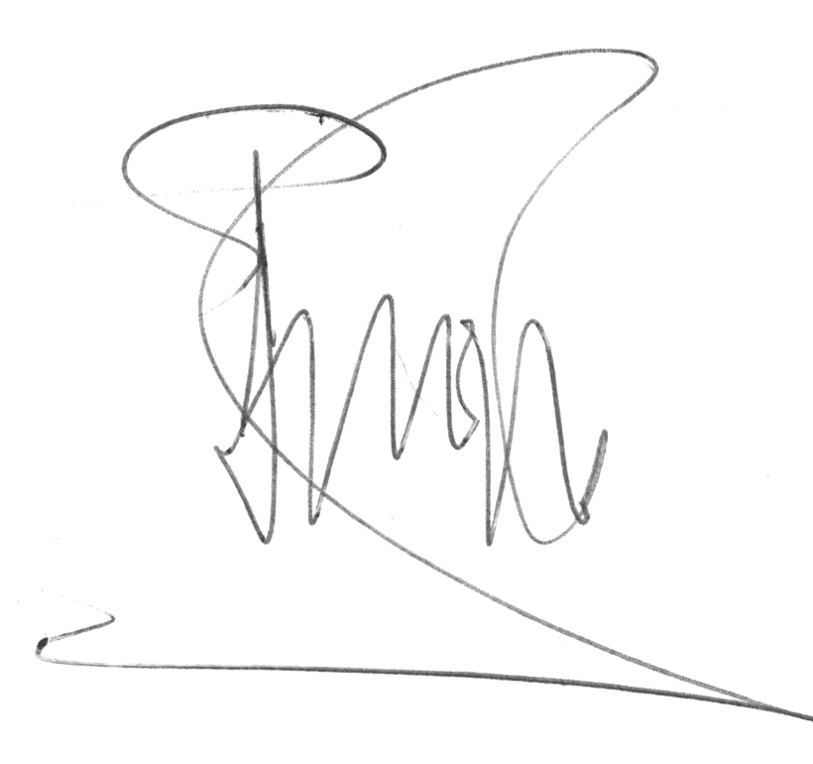
Simon Curtis

